Nicholas Ang

CS457

Project Assignment 5

PA5 Design Document - Bonus Project

The three aggregate query functions that are implemented are COUNT, AVG, and MAX. COUNT outputs the number of records to the user. AVG outputs the average value of the table for a numerical attribute. MAX outputs the highest value of the table for a numerical attribute.

COUNT generates the table from the file contents. Then as it iterates through the rows, it increments the line number counter. It counts the total number of lines in the table including the attributes row. The total number of records is the total number of lines in the table minus one. At the end, the total number of records is outputted to the terminal.

AVG generates the table from the file contents. It then searches for the column with the given attribute and gets its column number in the table. It iterates through the table that was generated and adds the values in the column of the given attribute. After everything is added, the average is calculated by the total sum divided by the total number of records which is the total number of lines minus 1. At the end, the average value is outputted to the terminal. The AVG aggregate query only works for numerical values.

Max generates the table from the file contents. It then searches for the column with the given attribute and gets its column number in the table. The max value is set to 0 at the start and it iterates through each row in the table. It compares the max value with the current value at the attribute’s column number. If the max value is greater than the current value, it will continue to iterate through. If the max value is lower than the current value, the current value is set as the new max value. At the end, the max value is outputted to the terminal. The MAX aggregate query only works for numerical values.

**Execution Instructions:** Please use the command *g++ p5.cpp -o p5* to compile the program and mainly use *./p5 PA5_test.sql* to run the test script with the program. If you want to test some commands, use the command *./p5* to start interactive mode. Interactive mode requires proper spacing in the command to be entirely correct for commands to work so follow the format of the commands in the test script. You should be able to simply copy and paste the commands from the script or type the commands manually if you are using interactive mode.

The image below shows the output in the terminal when the test script is run with the program.

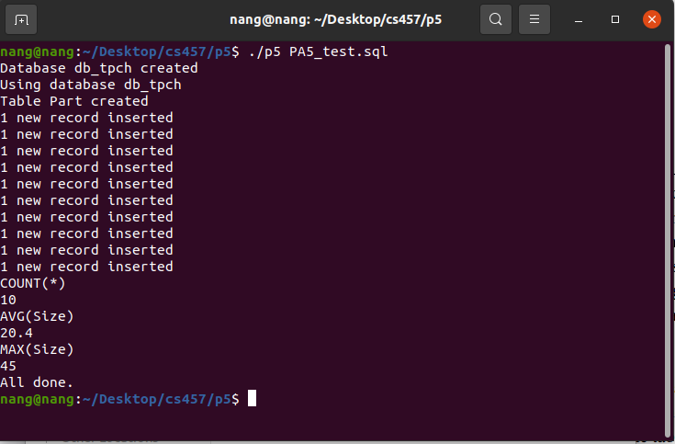

The image below shows the output in the terminal when the user inputs the commands one by one into the program in Interactive Mode.

